Install MEGA on either your MAC or PC:
MAC: Download MEGA X (https://www.megasoftware.net/) not MEGA 11
Windows; Only option is MEGA 11

STEP 1: Multiple Sequence Alignment
- Go to Entrez Gene or Ensemble to retrieve PROTEIN homologs (Ensemble can download .MEG files so it’s faster). Homologene you can download a FASTA file and convert to a MEG file in MEGA.
---Or you can copy/paste or upload your .txt file you have built. (NOTE this the major place where you need to troubleshoot the formatting)

Next steps are for just FASTA files:
- Export FASTA files for each model organisms to your desktop (name Human.fasta, etc).
- Click on your Human FASTA file. It should open MEGA
- Click Align File
- EDIT> Insert Sequences from File >
- They should all be in MEGA now

Alignments:
- To do MULTIPLE sequence alignment you have 2 methods: Clustal W or Muscle (you can try both). Click on the W in the toolbar to align using Clustal W or Click on the Arm icon to use Muscle.
- Now your sequences are aligned in MEGA to be used for the next step
- In toolbar on top: Select DATA>Export file as MEGA format (name Gene name Alignment.meg)

STEP 2: Build a tree in MEGA
10. Click on the Phylogeny button in MEGA
11. Select which type of method you want to choose (Neighbor joining or Maximum likelihood—try both)
11. Upload your Multiple sequence alignment file from your desktop (Gene NameAligment.meg)
12. Make sure you select BOOTSTRAP method in the window that pops up
13. Export tree as a PNG file: IMAGE> Save as PNG name it your gene+Method.png
*note maximum likelihood trees will take a long time to build, Neighbor joining is faster
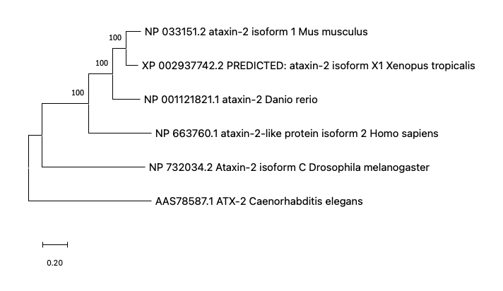
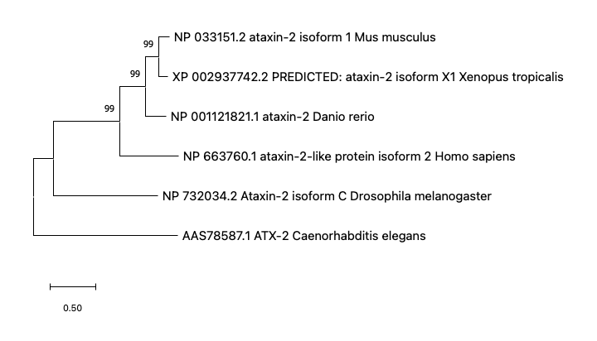
*BOOTSTRAPPING: In terms of your phylogenetic tree, the bootstrapping values indicates how many times out of 100 (in your case) the same branch was observed when repeating the phylogenetic reconstruction on a re-sampled set of your data.

Alternative ways to build a tree:
Align using Clustal Omega: https://www.ebi.ac.uk/Tools/msa/clustalo/

Then paste the alignment into:
Simple Phylogeny: https://www.ebi.ac.uk/Tools/phylogeny/simple_phylogeny/

